Matthew Hoffman

CpE 403 – Advanced Embedded Systems

CC1350 Lab 4

# Task 1- Importing the WSN Examples

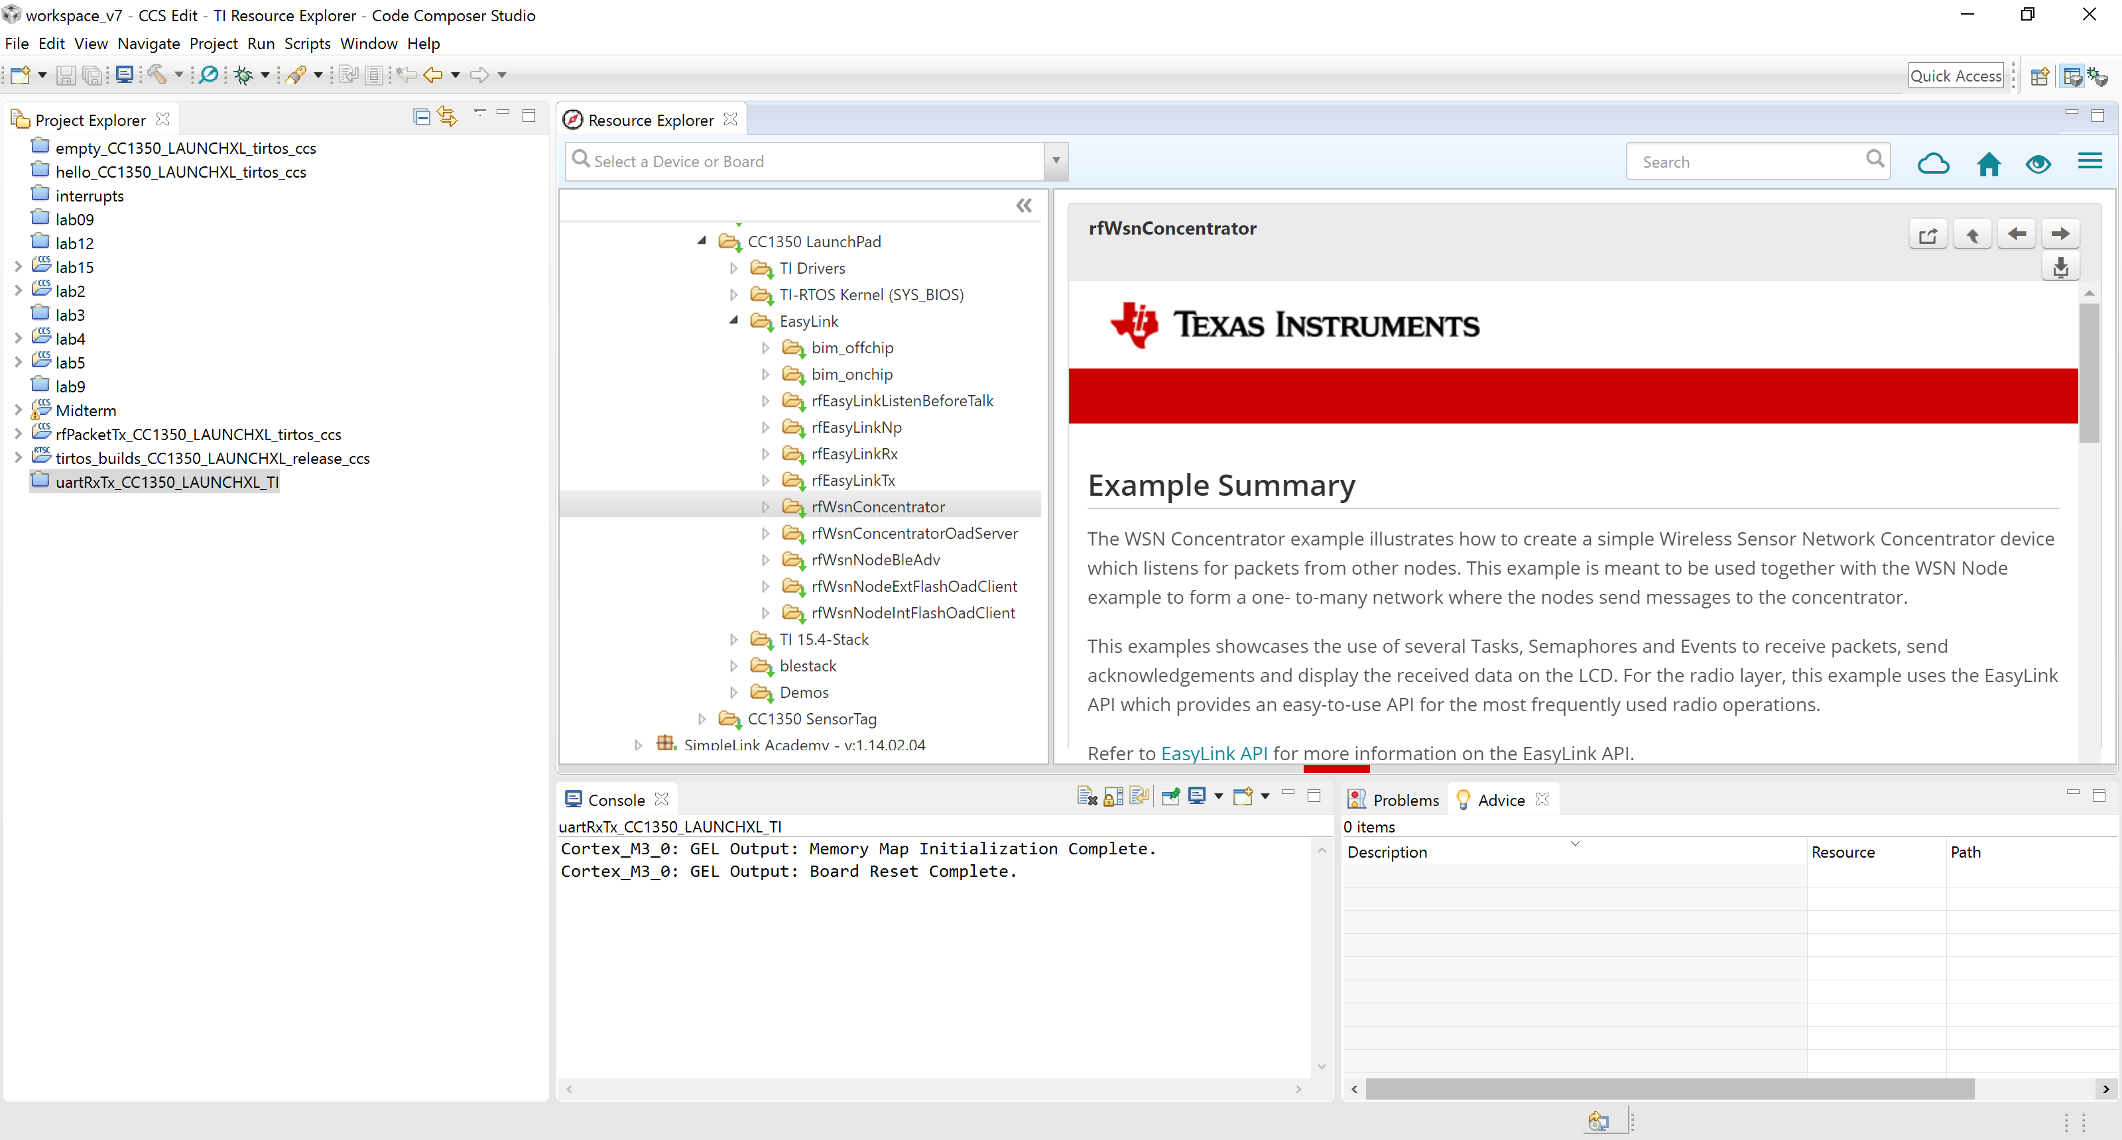

**Figure 1. Task 1.a - rfWsnConcentrator**

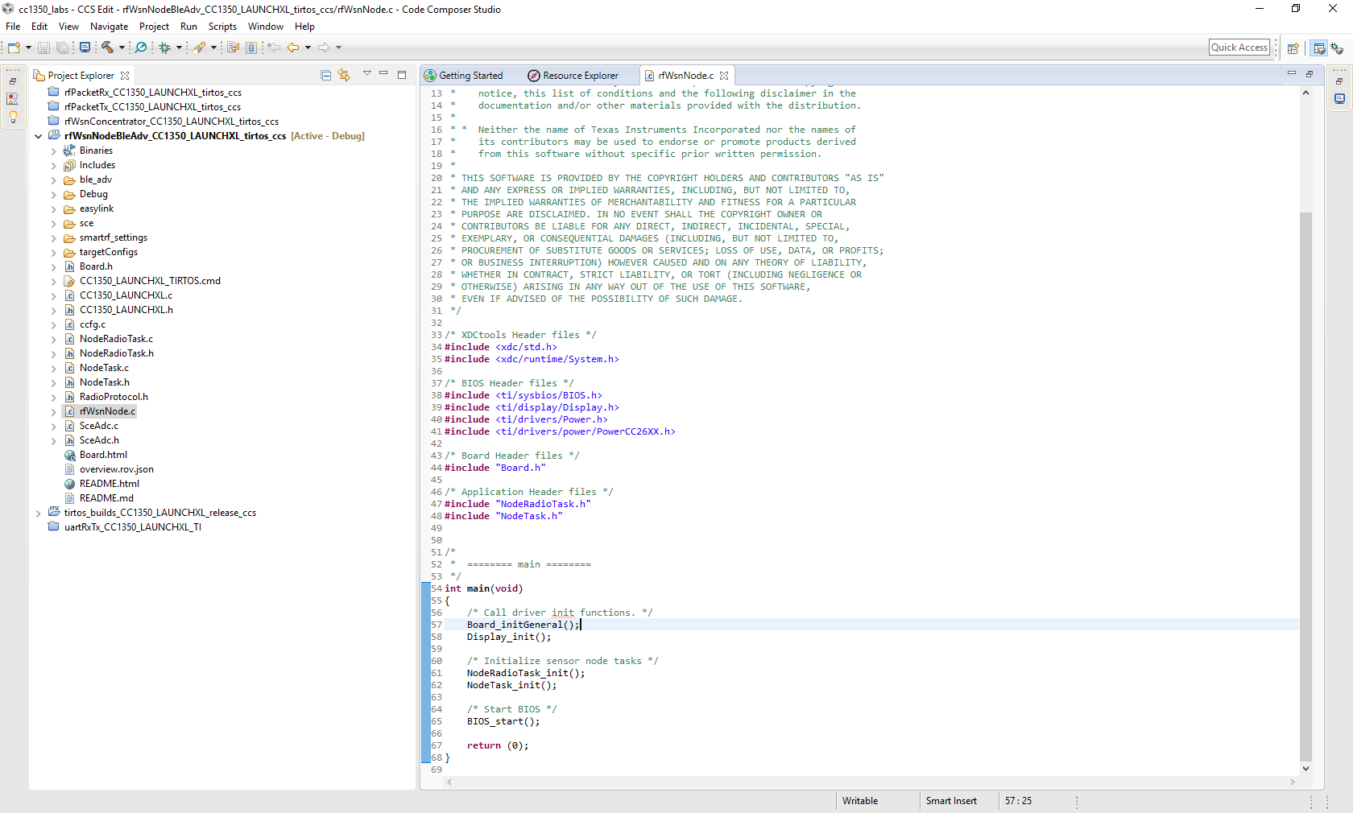

**Figure 2. Task 1.b – rfWsnConcentrator**

# Task 2 – Putting it all to work

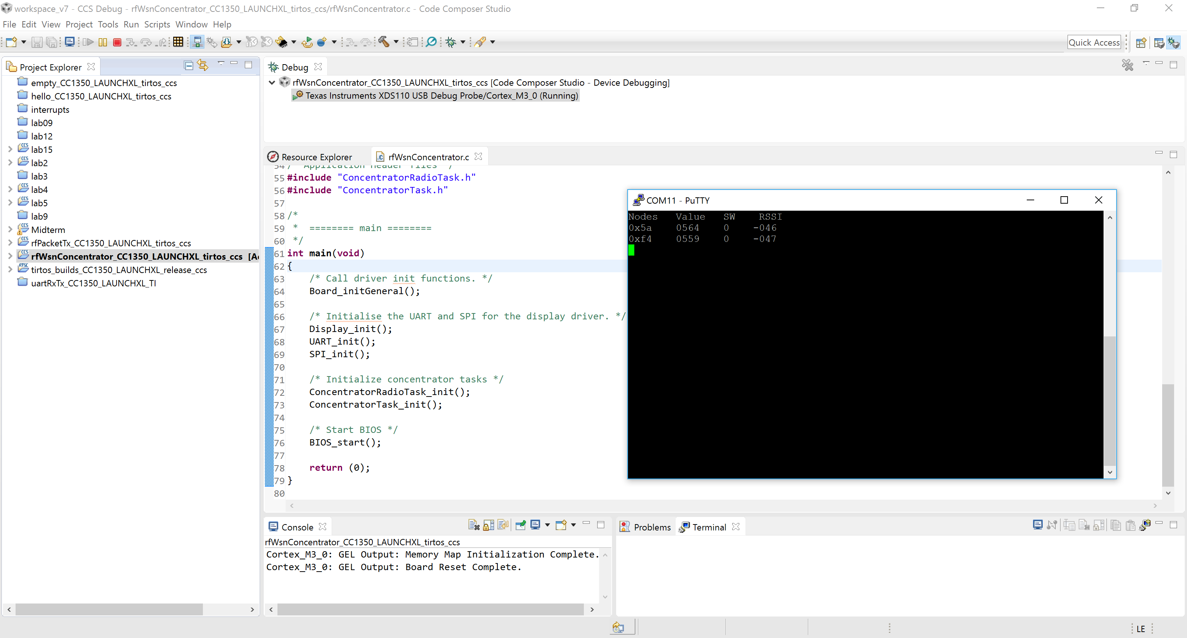

**Figure 3. Task 2.a – Node connections**

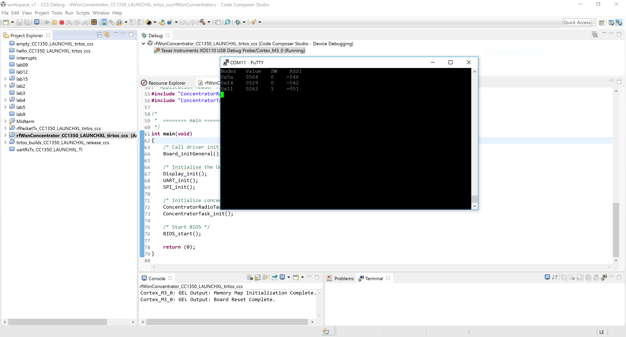

**Figure 4. Task 2.b – ADC Value defaults**

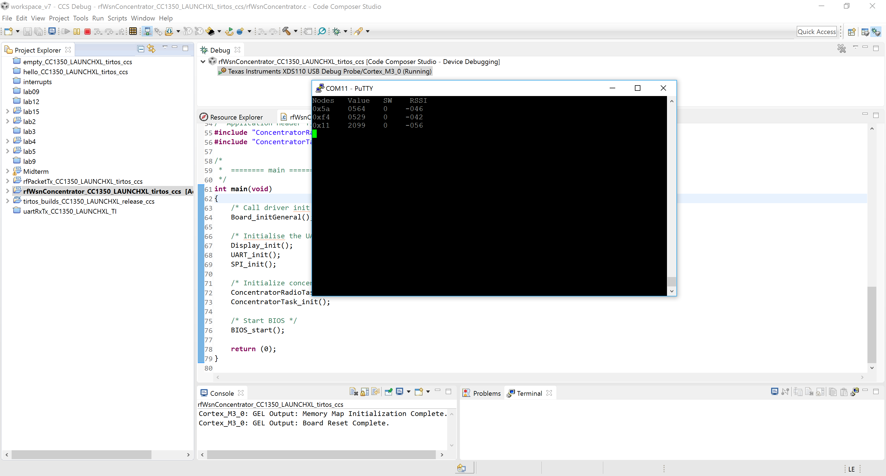

**Figure 5. Task 2.c – ADC Value with changed ADV values**

# Task 3 – Change RF Channel

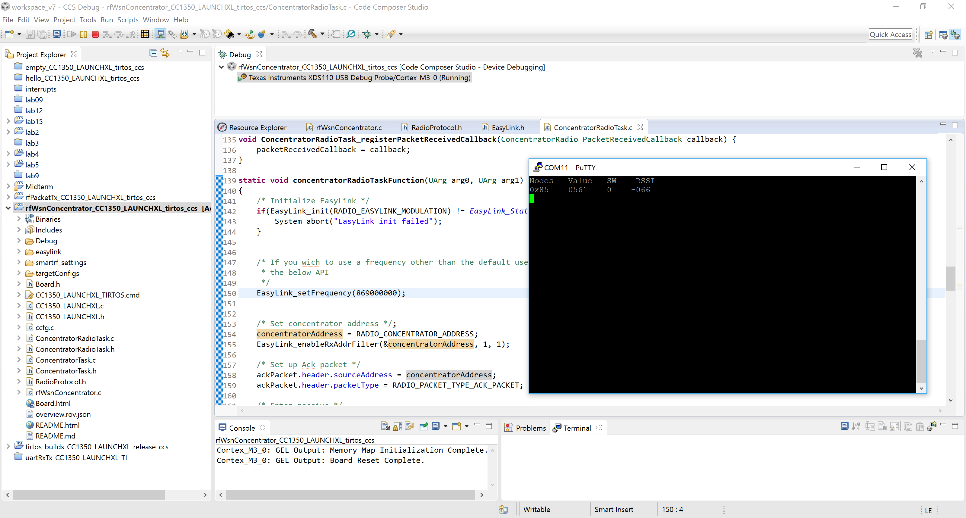

**Figure 6. Task 3.a Use of original frequency 868000000**

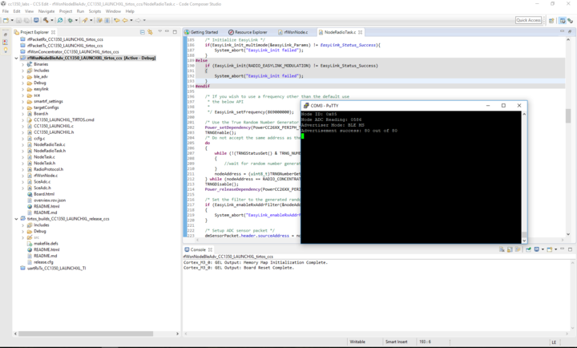

**Figure 7. Task 3.b Change of original frequency to 867000000**

# Task 4 – Switch from 2-GFSK 50 kbps to Long Range Mode (LRM)



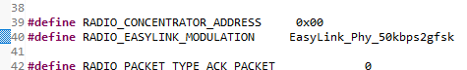

**Figure 8. Task 4 –Change of short to long range**

# Task 5 – Modify Code Running on the Sensor Controller

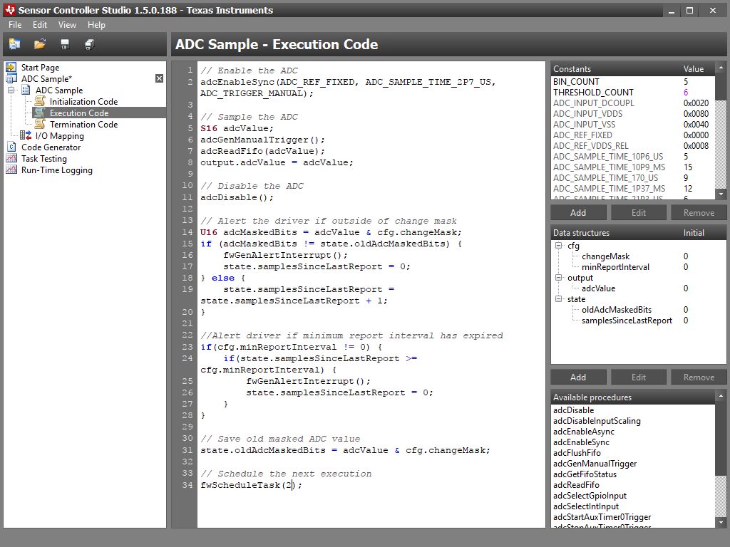

**Figure 9. Task 5.a – Sensor Controller Studio Execution Code**

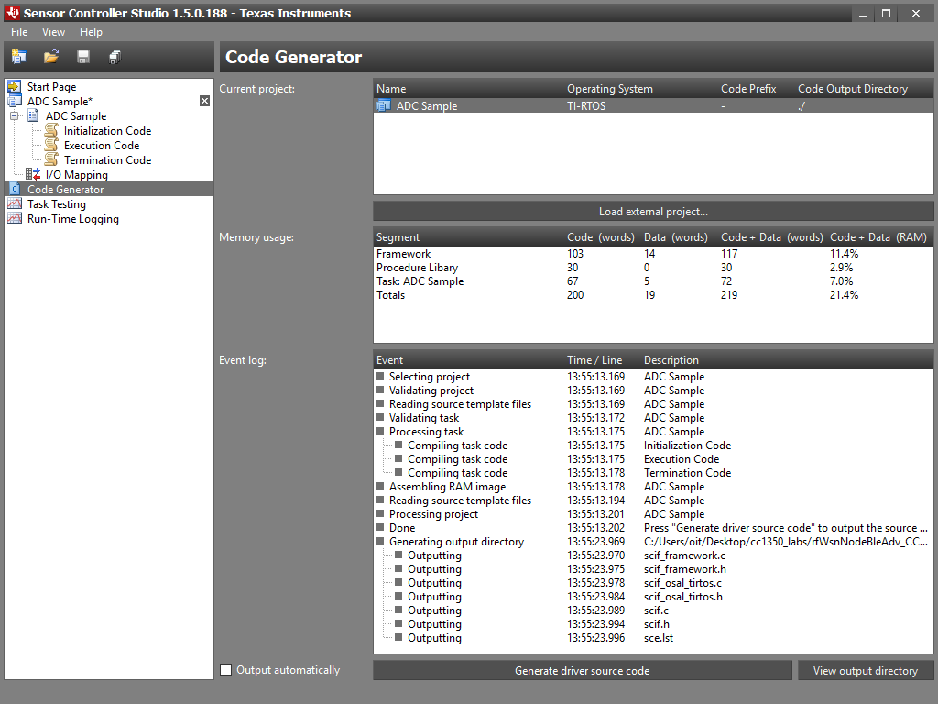

**Figure 10. Task 5.b – Code Generator. Sampling Change.**

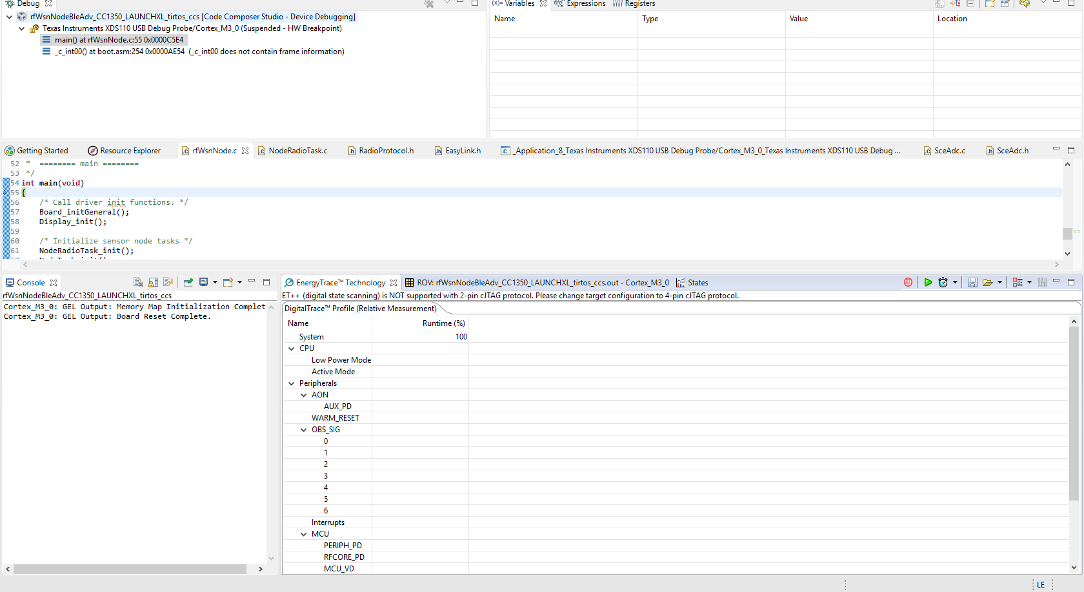

**Figure 11. Task 5.c – Energy Trace**